

Dental Clinic Management System
Business Requirements Document (BRD)

Version 1.1

Version and Approvals
UTORS

Version History
Version # | Date |  | Revised By | Reason for change
1.0 | November 4, 2024 |  | Group 10 (Assignment 1) | Initial Draft
1.1 | December 20, 2024 |  | Group 10 (Assignment 2) | Updated Use-Case Details

This document has been approved as the official Business Requirements Document for Dental Clinic Management System, and accurately reflects the current understanding of business requirements. Following approval of this document, requirement changes will be governed by the project’s change management process, including impact analysis, appropriate reviews and approvals.

Document Approvals
Approver Name | Project Role |  | Signature/Electronic Approval | Date
Arda DEMİR | Project Member |  |  | December 20, 2024
Atacan İSHAN | Project Member |  |  | December 23, 2024

Table of Contents

Project Details 1

Overview 1

Document Resources 1

Glossary of Terms 1

Project Overview 1
4.1 Project Overview and Background 1
4.2 Project Dependencies 2
4.3 Stakeholders 2

Key Assumptions and Constraints 2
5.1 Key Assumptions and Constraints 2

Use Cases 2
Use Case Diagram 2
Use Case Narrative 3

Business Requirements 5

Appendixes 7
Appendix A – Business Process Flows 7
Appendix B – Business Rules Catalog 10
Appendix C- Models 10
Traceability Matrix 10
Use Case Narrative Instructions 10

Project Details

Project Name | Dental Clinic Management System
Project Type
  New Initiative
Project Start Date | November 4, 2024
Project End Date | December 25, 2024
Project Sponsor | Dr. E. Aydın
Primary Driver | Efficiency
Secondary Driver
  Improved Patient Experience
Division | Healthcare Technology
Project Manager/Dept
  Çoruh Sarp Acar, Software Engineering Dept.

Overview

This document defines the high level requirements Dental Clinic Management System. It will be used as the basis for the following activities:

- Creating solution designs
- Developing test plans, test scripts, and test cases
- Determining project completion
- Assessing project success

Document Resources

Name | Business Unit | Role
Çoruh Sarp ACAR |  | Project Manager
  Software Engineering Dept.
Arda DEMİR | Software Engineering Dept. | Project Member
Atacan İSHAN | Software Engineering Dept. | Project Member
Ziya Berk ALAŞ | Software Engineering Dept. | Project Member
Baran Kemal YAZICI | Software Engineering Dept. | Project Member

Glossary of Terms

Term/Acronym | Definition
  BRD
  Business Requirements Document
  Patient
  An individual registering for dental services.
Dentist
  A healthcare provider offering dental treatments and managing appointments.
Admin
  A staff member overseeing system operations and management tasks.
SMS | Short Message Service, used for sending appointment reminders.

Project Overview

4.1 Project Overview and Background
The Dental Clinic Management System is a new initiative aimed at addressing operational inefficiencies in dental clinics. The current challenges include manual appointment scheduling, lack of centralized patient records, and no automated system for appointment reminders or inventory tracking.
Objectives:
- To automate appointment scheduling with real-time dentist availability.
- To securely manage patient profiles and treatment histories.
- To generate invoices and handle billing seamlessly.
- To provide inventory tracking to ensure adequate supply levels.
- To improve the overall experience for patients and streamline clinic operations.
This system will provide a user-friendly interface for patients, dentists, and administrative staff, ensuring better efficiency and satisfaction.

4.2 Project Dependencies
The Dental Clinic Management System relies on the following dependencies:
- Technology Infrastructure: The project depends on reliable hardware and software to host the application.
- Third-Party Services: Integration with SMS/email services for appointment reminders and notifications.
- Stakeholder Collaboration: Effective collaboration with clinic staff for requirement gathering and validation.
- Regulatory Compliance: Adherence to healthcare data protection laws such as GDPR for securing sensitive patient information.

4.3 Stakeholders
The following comprises the internal and external stakeholders whose requirements are represented by this document:

 | Stakeholders
1. | Patients
2.
  Dentists
3.
  Administrative Staff
4.
  System Developers
5. | Project Sponsor (Dr. E. Aydın)

Key Assumptions and Constraints

5.1 Key Assumptions and Constraints

# | Assumptions
1. | Clinic staff and dentists will actively participate in the requirement-gathering process.
2.
  Patients will access the system through desktop and mobile devices.
3.
  Third-party SMS and email services will function without disruptions.
4.
  The system will support at least 100 concurrent users efficiently.
5.
  Staff will be trained to operate the system upon deployment.
6. | Data migration from existing manual systems to the new system will be feasible.
# | Constraints
1. | The system must comply with GDPR and other healthcare data protection regulations.
2.
  Budget limitations may restrict advanced features.
3.
  Implementation must be completed within the specified timeline.
4.
  Stable internet connectivity is required for full system functionality.
5.
  Integration with external services (SMS/email) depends on third-party availability.
6. | The system must operate seamlessly across multiple devices and platforms.

Use Cases

Use Case Diagram

Use Case Narrative

Use Case ID: | UC2
Use Case Name: | Appointment Scheduling
Created By: | Group 10 | Last Updated By: | Group 10
Date Created: | December 2024 | Date Last Updated: | December 2024

Actors: | Patient, Dentist, Admin
Description: | Allows patients to book appointments with dentists based on availability.
Preconditions: | - Patient is registered in the system.  - Dentist availability is updated in the system.
Postconditions: | - Appointment is saved.  - Notifications are sent to the patient and dentist.
Normal Course: | - Patient logs in.  - Patient views available time slots for a dentist.  - Patient selects a time slot and confirms.  - System saves the appointment and sends notifications.
Alternative Courses: | If no slots are available, the system suggests alternative dates.
Exceptions: | Network connectivity issues prevent booking.
Includes: | - Patient Registration  - Dentist Availability Management
Priority: | High
Frequency of Use: | Frequent
Business Rules | Appointments cannot overlap.
Special Requirements: | Real-time updates for availability.
Assumptions: | Patients provide accurate contact details.
Notes and Issues: | To be resolved: Integration with SMS services.
Use Case Graphic | 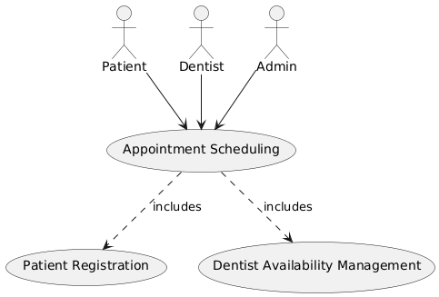

Use Case ID: | UC4
Use Case Name: | Treatment Records
Created By: | Group 10 | Last Updated By: | Group 10
Date Created: | December 2024 | Date Last Updated: | December 2024

Actors: | Dentist, Admin
Description: | Enables dentists to record and manage patient treatment details.
Preconditions: | Patient record exists in the system.
Postconditions: | Treatment details are saved securely.
Normal Course: | - Dentist logs in.  - Dentist selects a patient profile.  - Dentist enters treatment details.  - System saves the treatment records.
Alternative Courses: | If patient record does not exist, prompt to create a new record.
Exceptions: | Data loss due to system crashes.
Includes: | - Patient History Access  - Prescription Management
Priority: | Medium
Frequency of Use: | Regular
Business Rules | Only dentists can edit treatment records.
Special Requirements: | Secure access to sensitive medical data.
Assumptions: | Treatment details are entered immediately after the procedure.
Notes and Issues: | To be resolved: Adding a print option for records.
Use Case Graphic | 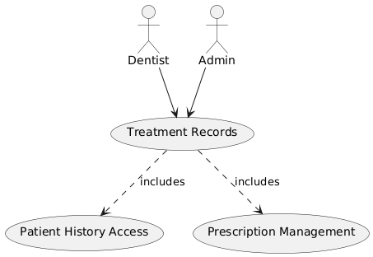

Use Case ID: | UC8
Use Case Name: | Inventory Tracking
Created By: | Group 10 | Last Updated By: | Group 10
Date Created: | December 2024 | Date Last Updated: | December 2024

Actors: | Admin, System
Description: | Tracks dental supplies and notifies the admin for restocking.
Preconditions: | Initial inventory data is set up in the system.
Postconditions: | Restocking notifications are generated.
Normal Course: | - System monitors stock levels.  - Admin views inventory data.  - System generates low-stock alerts if applicable.
Alternative Courses: | If critical stock is depleted, an immediate notification is sent.
Exceptions: | Incorrect stock data due to input errors.
Includes: | - Notification System  - Inventory Adjustment
Priority: | High
Frequency of Use: | Weekly
Business Rules | Inventory must be checked daily.
Special Requirements: | Alerts must be sent via email.
Assumptions: | Stock levels are updated in real-time.
Notes and Issues: | To be resolved: Integration with supply vendors.
Use Case Graphic | 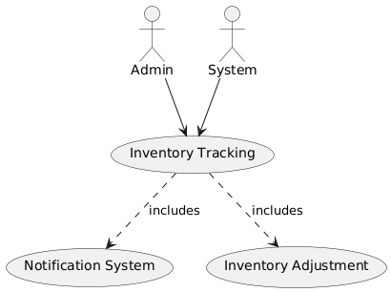

Business Requirements

The following sections document the various business requirements of this project.

Requirement Type | ID – Prefix | ID – Number | Function – Feature - Requirement | Use Case Reference | Required | Priority | Frequency of Use | Risk Level | Comments
 | Business User Requirements
BUR | f | 0001 |  | UC2 | Y  e  s | High |  | High | Core feature for patients.
  Allow patients to schedule appointments
  Daily
BUR | f | 0002 |  | UC4 | Y  e  s | High | Weekly | Medium
  Enable dentists to manage treatment records
  Essential for maintaining patient care.
BUR | f | 0003 |  | UC8 | Y  e  s | Medium | Monthly | Low
  Track inventory and send restock alerts
  Critical for clinic operations.
BUR | f | 0004 |  | UC2 | Y  e  s | High |  | High
  Enable real-time dentist availability updates
  Daily
  Required for efficient scheduling.
BUR | F | 0005 |  | UC2 | Y  e  s |  |  | Medium
  Provide a summary of past appointments
  Medium
  Weekly
  Enhances patient experience.
BUR | F | 0006 |  | UC4 | Y  e  s | High |  | Medium
  Allow treatment record updates
  Weekly
  Required for accurate medical records.
BUR | f | 0007 |  | UC8 | Y  e  s |  | Monthly | Low
  Display inventory usage history
  Medium
  Useful for supply management.
BUR | f | 0008 |  | UC2 | Y  e  s |  |  | Medium | Important for scalability.
  Support multi-clinic scheduling
  Medium
  Monthy
 | Reporting Requirements
RR | f | 0001 |  | UC2 | Y  e  s | High | Weekly | Medium
  Generate reports on scheduled appointments
  Core feature for clinic reporting.
RR | f | 0002 |  | UC4 | Y  e  s | High | Weekly | Medium
  Generate reports on treatment records
  Essential for medical documentation.
RR | f | 0003 |  | UC8 | Y  e  s | Medium | Monthly | Low
  Provide inventory status reports
  Important for supply tracking.
RR | f | 0004 |  | UC2 | Y  e  s | Medium | Weekly | Medium
  Generate weekly appointment trends
  Useful for analyzing patient behavior.
RR | F | 0005 |  | UC4 | Y  e  s | Medium | Monthly | Medium
  Provide monthly treatment summaries
  Necessary for dentist performance reviews.
RR | F | 0006 |  | UC8 | Y  e  s | Medium | Monthly | Low
  Track inventory restock frequency
  Optimizes supply orders.
RR | f | 0007 |  | UC8 | Y  e  s | High | Daily | High
  Generate real-time low inventory alerts
  Critical for operational efficiency.
RR | f | 0008 |  | UC2 | N  o | Low | Montly | Low | Optional feature for patient use.
  Export patient appointment history
 | User Access/Security Requirements
UA | f | 0001 |  |  | Y  e  s | High | Daily | High
  Role-based access for all users
  UC2, UC4, UC8
  Ensures data security for all actors.
UA | f | 0002 |  | UC4 | Y  e  s | High | Daily | High
  Encrypt sensitive patient data
  Required for GDPR compliance.
UA | f | 0003 |  |  | Y  e  s | High | Daily | High
  Secure authentication for all users
  UC2, UC4, UC8
  Prevents unauthorized access.
UA | f | 0004 |  | UC8 | Y  e  s | Medium | Weekly | Medium
  Provide secure access to inventory
  Protects inventory data integrity.
UA | F | 0005 |  | UC2, UC4, UC8 | Y  e  s | Medium | Daily | Medium
  Log all system actions for auditing
  Ensures accountability and traceability.
UA | F | 0006 |  | UC2, UC4, UC8 | Y  e  s | High | Daily | High
  Timeout inactive sessions
  Improves security for unattended sessions.
UA | f | 0007 |  | UC8 | N  o | Low | Rarely | Medium
  Multi-factor authentication for admin
  Optional for enhanced security.
UA | f | 0008 |  | UC4 | Y  e  s | High | Daily | High | Protects confidentiality of patient records.
  Limit patient access to their own data
 | Service Level/Performance Requirements
SL | f | 0001 |  | UC2 | Y  e  s |  | Daily
  Real-time dentist availability updates
  High
  High
  Ensures efficient scheduling.
SL | f | 0002 |  | UC2, UC4, UC8 | Y  e  s |  | Daily
  Ensure system uptime of 99.9%
  High
  High
  Critical for clinic operations.
SL | f | 0003 |  | UC8 | Y  e  s |  | Real-Time
  Process inventory updates in 1 second
  High
  High
  Necessary for accurate stock tracking.
SL | f | 0004 |  | UC4 | Y  e  s |  | Daily | Medium
  Provide treatment record access in under 2 seconds
  High
  Improves user experience.
SL | F | 0005 |  | UC2, UC4, UC8 | Y  e  s |  | Daily
  Support 100 concurrent users
  High
  High
  Ensures system stability.
SL | F | 0007 |  | UC8 | Y  e  s |  | Real-Time
  Send low-inventory alerts in real-time
  High
  High
  Enhances operational efficiency.
SL | f | 0007 |  | UC4 | Y  e  s | Medium | Weekly | Medium
  Load detailed treatment reports within 5 seconds
  Useful for performance reporting.
SL | f | 0008 |  | UC2 | Y  e  s |  | Daily |  | Improves patient satisfaction.
  Support appointment scheduling in 1 second
  High
  High
 | Scalability Requirements
SR | f | 0001 |  | UC2, UC4, UC8 | Y  e  s |  |  | Medium
  Allow integration with additional clinics
  High
  Rarely
  Important for future growth.
SR | f | 0002 |  | UC2, UC4, UC8 | Y  e  s |  | Daily | Medium
  Enable multi-device access (desktop, mobile)
  High
  Enhances user accessibility.
SR | f | 0003 |  | UC2, UC4, UC8 | Y  e  s |  | Daily | Medium
  Support 100 concurrent users
  High
  Ensures system stability.
SR | f | 0004 |  | UC8 | Y  e  s | Medium | Monthly | Medium
  Provide API for third-party tools
  Useful for extending functionality.
SR | F | 0005 |  | UC2, UC4, UC8 | Y  e  s |  |  | Medium
  Scale storage for increasing data
  High
  As Needed
  Critical for large-scale operations.
SR | F | 0007 |  | UC2, UC4, UC8 | N  o | Low |  | Low
  Support multi-language functionality
  Rarely
  Optional for international use.
SR | f | 0007 |  | UC4, UC8 | N  o | Low |  | Low
  Provide offline admin access
  Rarely
  Useful for emergencies.
SR | f | 0008 |  | UC2 | Y  e  s |  |  | Medium | Important for expansion.
  Add clinics dynamically
  High
  As Needed
 | Support and Maintenance Requirements
S&MR | f | 0001 |  |  | Y  e  s | High | Once | Medium
  Provide training materials for staff
  UC2, UC4, UC8
  Ensures proper onboarding.
S&MR | f | 0002 |  |  | Y  e  s | High | Daily | High
  Offer 24/7 technical support
  UC2, UC4, UC8
  Critical for uninterrupted usage.
S&MR | f | 0003 |  |  | Y  e  s | High |  | Medium
  Regular updates and patches
  UC2, UC4, UC8
  Monthly
  Maintains system stability.
S&MR | f | 0004 |  |  | Y  e  s | Medium |  | Medium
  Document all feature changes in release notes
  UC2, UC4, UC8
  Per Update
  Enhances transparency.
S&MR | F | 0005 |  | UC8 | N  o | Medium | Weekly | Low
  Provide a system health monitoring dashboard
  Useful for advanced monitoring.
S&MR | F | 0007 |  |  | Y  e  s | High | Daily | High
  Maintain backup servers
  UC2, UC4, UC8
  Critical for disaster recovery.
S&MR | f | 0007 |  |  | Y  e  s | High | Daily | Medium
  Provide email and chat-based support
  UC2, UC4, UC8
  Improves user satisfaction.
S&MR | f | 0008 |  |  | N  o | Low | Rarely | Medium | Optional for advanced security.
  Offer bug bounty programs for system vulnerabilities
  UC2, UC4, UC8

Appendixes

Appendix A – Business Process Flows

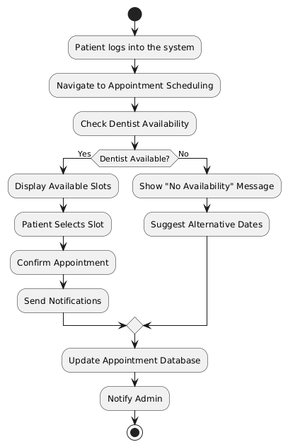

As Is Diagrams

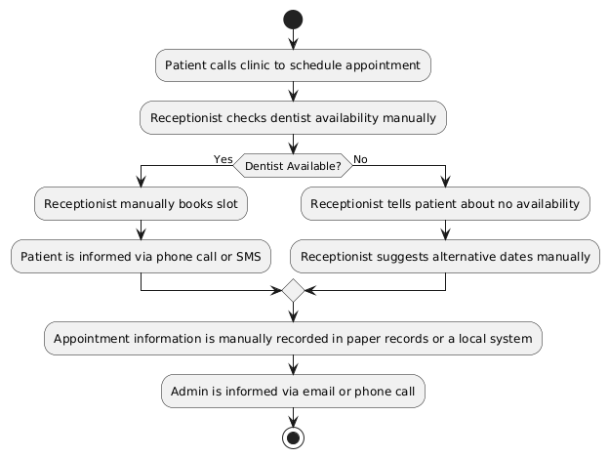
To Be Diagrams
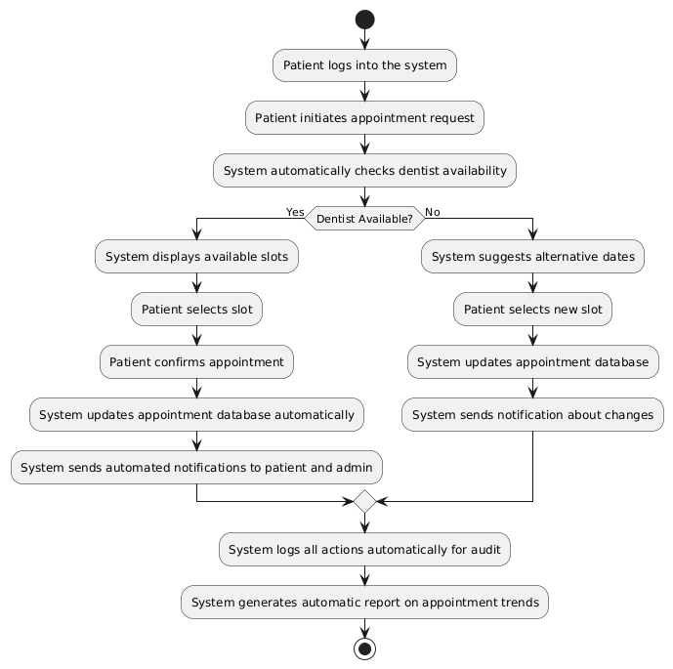

Appendix B – Business Rules Catalog
Business Rule Name: | Appointment Availability
Identifier | BR1
Description | A dentist’s availability must be checked before allowing a patient to book an appointment. If no available slots are found, the system should suggest alternative dates or dentists.
Example | If Dr. Ercüment is fully booked on a particular day, the system should display available time slots for Dr. Ercüment on other days or suggest another available dentist.
Source | Stakeholder (Dentist Office Manager)
Related Rules | 1.The system should allow the patient to select an alternative dentist or date if no availability is found.  2.The appointment scheduling system must ensure that it can update the available dentist slots in real-time.

Business Rule Name: | Patient Login Validation
Identifier | BR2
Description | Only registered patients can log in to the system. The system must authenticate the patient’s credentials before granting access to the appointment scheduling system.
Example | A user tries to log in with incorrect credentials. The system prompts them to re-enter their username and password or reset their password.
Source | Stakeholder (Security Officer)
Related Rules | 1.The system must ensure the patient's credentials are securely verified.  2.If the login fails multiple times, the system should lock the account temporarily and prompt for security questions.

Business Rule Name: | Appointment Confirmation
Identifier | BR3
Description | Once a patient selects a time slot, they must confirm the appointment. The system should send a confirmation message to both the patient and the dentist.
Example | After selecting a time slot, the patient receives an email and an SMS with the details of the confirmed appointment.
Source | Stakeholder (Patient Services)
Related Rules | 1.After confirming an appointment, a notification should be sent to the dentist.  2.If the patient cancels an appointment, the system should automatically notify the dentist and update the slot availability.

Business Rule Name: | Password Reset Process
Identifier | BR4
Description | If a patient forgets their password, the system should allow them to reset it by sending a secure reset link to their registered email.
Example | A patient clicks on "Forgot Password," receives an email with a link to reset their password, and can then create a new password.
Source | Stakeholder (Security Officer)
Related Rules | 1.After resetting the password, the system should log out any active sessions for security.  2.The password reset process must be encrypted to protect patient data.

Business Rule Name: | Automated Notifications
Identifier | BR5
Description | The system should send automated notifications to both the patient and the dentist for each appointment action (e.g., booking, rescheduling, cancellation). Notifications should include date, time, and dentist information.
Example | Upon confirming an appointment, both the patient and the dentist receive an email and an SMS with the appointment details.
Source | Stakeholder (Patient Services)
Related Rules | 1.The notification system should allow customization for both the patient and dentist.  2.Notifications should also include reminders 24 hours before the scheduled appointment.

Business Rule Name: | System Logs and Auditing
Identifier | BR6
Description | All actions taken by patients and administrators within the system should be logged for auditing purposes. This includes login attempts, appointment bookings, and changes made to patient information.
Example | When a patient books an appointment, a log entry is created with their username, the selected time slot, and the date of the transaction.
Source | Stakeholder (Compliance Officer)
Related Rules | 1.Logs should be stored securely and be retrievable for compliance audits.  2.The system should track changes made to patient data, including who made the change and when.

Business Rule Name: | Alternative Date Suggestions
Identifier | BR7
Description | If a patient tries to book an appointment when no slots are available, the system should automatically suggest alternative dates within the next 7 days.
Example | A patient attempts to book an appointment for tomorrow, but the system informs them that no slots are available and suggests appointments for the next 5 days.
Source | Stakeholder (Appointment Scheduler)
Related Rules | 1.The system should prioritize suggesting alternative dates that are within the same specialty or dentist.  2.If no dates are available within the next 7 days, the system should suggest another dentist with open slots.

Appendix C- Models

1. Use Case Diagram
A Use Case Diagram illustrates the interactions between different actors (such as patients, dentists, and administrators) and the system. The diagram shows the key functionalities of the system from the user's perspective.
Actors:
1.Patient: Books an appointment, logs in to the system, selects available slots.
2.Dentist: Manages availability, confirms appointments.
3.Administrator: Manages users and appointments, views reports.
Use Cases:
a.Patient logs into the system.
b.Patient checks available appointment slots.
c.Patient books an appointment.
d.Administrator manages system settings.

2. Activity Diagram
An Activity Diagram represents the flow of activities during the appointment booking process. It outlines the sequence of actions taken by the patient and the system.
Activities:
1.Patient logs into the system.
2.Patient navigates to the appointment scheduling page.
3.The system checks dentist availability.
4.If a dentist is available, the patient selects a time slot.
5.System confirms the appointment and sends notifications.

3. Sequence Diagram
A Sequence Diagram illustrates how objects interact in a particular sequence of events. For example, when a patient attempts to book an appointment, this diagram shows the interactions between the patient, the system, and the dentist.
Objects:
1.Patient
2.System
3.Dentist
Process:
1.Patient logs in.
2.Patient requests available slots.
3.System checks availability.
4.Patient selects a slot.
5.System confirms appointment and sends notifications.

4. Data Flow Diagram (DFD)
The Data Flow Diagram (DFD) represents how data moves through the system, showing the inputs, outputs, and processing steps involved in the appointment scheduling process.
Data Stores:
1.Patient Database: Stores patient details.
2.Appointment Database: Stores appointment details.
3.Dentist Availability: Stores dentist availability schedules.
Processes:
1.User login validation.
2.Appointment scheduling.
3.Sending notifications.

5. Entity-Relationship Diagram (ERD)
The Entity-Relationship Diagram (ERD) shows the relationships between different entities in the system's database, such as patients, appointments, and dentists.
Entities:
1.Patient: Contains patient details.
2.Appointment: Contains appointment information (date, time, dentist).
3.Dentist: Contains dentist details (availability, schedule).
Relationships:
1.A patient can book multiple appointments.
2.A dentist can have multiple appointments.

6. State Diagram
A State Diagram models the different states that an appointment can go through, from being unconfirmed to confirmed or canceled.
States:
1.Scheduled: The appointment is scheduled but not yet confirmed.
2.Confirmed: The appointment has been confirmed by the dentist and patient.
3.Canceled: The appointment has been canceled by either the patient or the dentist.

Traceability Matrix
Business Requirement | Functional Requirement | Test Case ID | Test Description | Test Status
Appointment Availability | Check dentist's availability before booking | TC-01 | Test if system checks dentist availability for booking | Pending
Patient Login Validation | User authentication and validation for registered patients | TC-02 | Test if the system successfully authenticates registered patients | Pending
Appointment Confirmation | Once a time slot is selected, system should confirm appointment | TC-03 | Test if the system sends confirmation messages upon appointment booking | Pending
Password Reset Process | Provide password reset functionality for patients | TC-04 | Test if the system allows patients to reset their passwords | Pending
Automated Notifications | Send notifications to patient and dentist for each action | TC-05 | Test if the system sends notifications for appointment actions (booking, rescheduling, cancellation) | Pending
System Logs and Auditing | Log actions taken by patients and administrators for auditing | TC-06 | Test if the system logs user actions correctly | Pending
Alternative Date Suggestions | Suggest alternative dates if no available slots are found | TC-07 | Test if the system suggests alternative appointment dates when no slots are available | Pending

Use Case Narrative Instructions

Use Case Field Name | Definition
Use Case ID: 1.1 | A unique numeric identifier assigned to the use case, typically written in hierarchical form (e.g., 1.1). Related use cases are grouped together. This ID can be referenced in the traceability matrix.
Use Case Name: Schedule Appointment | A concise, action-oriented name that clearly describes the main task or goal of the use case. It typically includes a verb and a noun, such as "Schedule Appointment" or "Login to System."
Created By: Atacan İSHAN | The name of the person or team who initially documented the use case.
Date Created:23.12.2024 | The date on which the use case was first documented, indicating when it was added to the project.
Date Last Updated:24.12.2024 | The date on which the use case was most recently updated, reflecting any changes or refinements.
Last Updated By: Atacan İSHAN | The name of the person who made the most recent modifications to the use case description.
Actor:  - Patient: The user who schedules an appointment with a dentist.  - Dentist: The professional who the patient is booking an appointment with. | An individual or external system interacting with the software to achieve the goal of the use case. Common actors might include system users (e.g., "Patient") or external systems.
Description:  The "Schedule Appointment" use case allows a registered patient to book an appointment with a dentist by selecting an available time slot. The system checks the dentist's availability and confirms the appointment. The outcome is a confirmed appointment for both the patient and the dentist. | A brief overview of the use case’s purpose or goal. This includes a high-level explanation of what is accomplished when the use case is executed. It answers "What is this use case for?"
Preconditions:  - The patient must be logged into the system.  - The system must have access to the dentist’s availability data. | Conditions that must be met or activities that must occur before the use case can start. These are requirements for the system or user before the use case can be performed.
Post conditions:  - The appointment is successfully booked and confirmed in the system.  - A notification is sent to both the patient and the dentist regarding the appointment details. | The state of the system after the use case has been executed. This includes the resulting changes or outcomes from performing the use case, such as confirmed appointments or error states.
Normal Course:  - Patient logs into the appointment scheduling system.  - System verifies the credentials of the patient.  - Patient navigates to the appointment scheduling page.  - System displays a list of available dentists and their available time slots.  - Patient selects a dentist and a time slot.  - System checks if the selected time slot is still available.  - System confirms the appointment and updates the schedule.  - System sends an email and an SMS notification to the patient and dentist confirming the appointment. | A detailed, step-by-step description of the actions taken by the actor and the responses from the system. It covers the expected and typical flow of actions to achieve the use case's goal.
Alternative Courses:  1.1.AC.1 – Dentist Not Available:  1. If the selected dentist is unavailable for the chosen time slot, the system will display a "No availability" message.  2. The system will suggest alternative time slots or alternative dentists to the patient.  3. If the patient selects a new time or dentist, the normal course resumes from step 6. | Describes different legitimate scenarios or deviations that may occur during the use case execution. For example, if certain conditions are not met, the system might respond differently.
Exceptions:  1.1.EX.1 – Invalid Login Credentials:  1. If the patient enters invalid login credentials, the system will prompt the patient to re-enter the correct information or reset their password.  2. The use case cannot proceed until the patient successfully logs in.  1.1.EX.2 – System Error:  1. If the system encounters a technical error when checking the dentist's availability, an error message will be displayed to the patient, and the process will halt.  2. The system will log the error and notify the administrator. | Anticipated error conditions that could occur during execution, such as system failures, invalid data, or actions by the actor that lead to error states. This also describes how the system will handle such errors.
Includes:  1.2: Confirm Appointment  1.3: Send Notification | Lists other use cases that are included within this one. These are common actions that may appear in multiple use cases, such as "Login" or "Confirm Appointment."
Priority:  High – This use case is essential for the core functionality of the appointment scheduling system. | The relative priority of implementing the functionality of the use case in the overall system. This could be based on business importance, system dependencies, or criticality.
Frequency of Use:  Likely to be used several times per day by each registered patient for scheduling appointments. | An estimate of how often this use case is likely to be executed, such as multiple times per day or once per week. This helps in understanding the system's expected load.
Business Rules:  Appointment Availability: The system must check if the selected time slot is available before confirming the appointment.  Patient Login Validation: Only authenticated users (registered patients) can schedule appointments. | A list of business rules that affect or govern the execution of the use case. These could be operational or functional constraints, such as "Only authenticated patients can schedule appointments."
Special Requirements:  Performance requirement: The system should check the dentist's availability in real time and process the scheduling request within 5 seconds.  Security requirement: Ensure that patient and dentist information is protected with encryption during the scheduling process. | Non-functional requirements that need to be addressed, like performance, security, or scalability concerns. Examples include "The system should respond within 5 seconds."
Assumptions:  Patients have already registered and have valid login credentials.  Dentists have up-to-date availability data in the system. | Conditions or beliefs assumed to be true for the analysis and design of the use case. For example, "Patients have valid login credentials."
Notes and Issues:  The system should provide feedback to the patient if an appointment cannot be scheduled due to system unavailability.  The admin is responsible for ensuring the dentist's availability data is accurate and up to date. | Any open issues, questions, or additional considerations related to the use case. These might include requirements that still need to be finalized or clarified.

